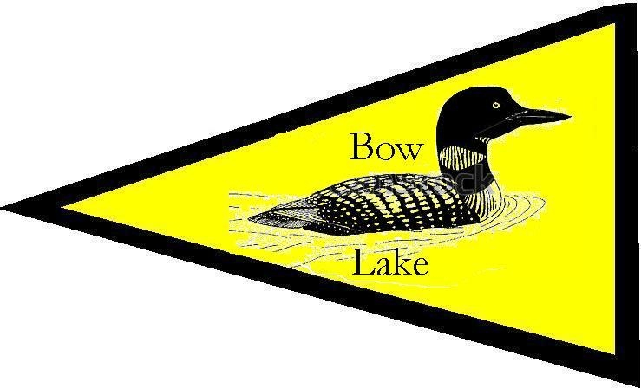 | Bow Lake Sailing RC Laser Regatta  Sponsored by Bow Lake Sailing  Saturday, September 24, 2022  Bow Lake, Strafford, NH  Notice of Race (NoR)

Bow Lake Sailing has a new and growing RC Laser Fleet and we want to share a terrific venue and hospitality with other RC Laser skippers. This is our second annual RC Laser event and we welcome all RC Laser skippers to join us for a fun day of racing.

- RULES
  - The event is governed by the rules as defined in The Racing Rules of Sailing and Appendix E.
  - No US Sailing Prescriptions apply except Appendix R and prescriptions to rules 60.3, 61.4, 67, 70.5(a), 76.1.
- VENUE
  - Bob Shapiro’s house on Bow Lake, 7 Fire Rd 144, Strafford, NH 03884. Turn onto dirt road Fire Rd 14 go 100 yards. At end turn right onto dirt/grass road Fire Rd 144. Park on the right – please pack the cars in tightly. Walk past the 2-story earth toned house to the water.
- SAILING INSTRUCTIONS
  - The sailing instructions will be available after 10:00 AM on Saturday September 24, 2022 at the sailing venue. Sailing instructions may be verbal.
- ELIGIBILITY, ENTRY AND FEES
  - The regatta is open to all boats of the RC Laser class.
  - The event fee is $20 per boat. Entry fees include racing, refreshments, lunch and trophies for the first 3 boats.
  - The deadline for entry is September 23, 2022. Prior to September 23, 2022 refunds will be issued minus a $10 processing fee. After September 23, 2022 there will be no refunds.
  - Online registration is preferred at <URL>. If that is not possible, please use the attached registration form and submit it, together with the required fee in a check made payable to Bow Lake Sailing, to Bob Shapiro, 8 Webber St, Wilmington, MA 01887 by September 17, 2022.
  - There will be a maximum of 20 entries.

- SCHEDULE
Date | Time | Activity
Saturday, September 24, 2022 | 0830 – 1000 | Check-in, Equipment Inspection, Certification check
 | 1000 | Skipper’s Meeting
 | 1030 | First scheduled Warning
 | 1230-ish | Break for lunch
 | 1600 | No Warning after this time
 | 1630 | Awards / Social
- SCORING
  - The Low Point System of Appendix A will be used, with the following races excluded from a boat’s score – 1 exclusion after 4 races, 2 exclusions after 8 races, 3 exclusions after 16 races, 4 exclusions after 24 races.
  - If more than 16 boats are scheduled to race, the Heat Management System (most current version) may be used with a 4 boat promotion. If the Heat Management System is used, HMS 1.8 (b) is deleted.
  - A minimum of 1 completed races are required to constitute a regatta.
- RISK STATEMENT
  - RRS 3 states: “The responsibility for a boat’s decision to participate in a race or to continue to race is hers alone.” By participating in this event each competitor agrees and acknowledges that sailing is a potentially dangerous activity with inherent risks.
- PRIZES
  - Prizes will be given as follows: Prizes will be awarded to the first 3 boats.
- FURTHER INFORMATION
  - For further information please contact Bob Shapiro, finallybk@gmail.com, 978-761-3289

Additional Information

- Please arrive so that you will be ready to race immediately after the skipper’s meeting.
- Depending on wind direction, venue may be switched to another location on Bow Lake at the last minute. Check your email the day before and day of the regatta.
- Limited housing may be available in local homes for people driving long distances. Contact Bob Shapiro with any housing requests.
- The Bow Lake Sailing RC Laser Fleet has a number of loaner boats available. Please contact Bob Shapiro if you would like to race but cannot bring your own boat.

Bow Lake Sailing RC Laser Regatta

Entry Form

Name: _______________________________ AMYA #:_________________

City: __________________________ State: _____ Phone #: _______________

Club: __________________________________________________

Email Address: __________________________________________

Emergency contact name: _________________________________

Emergency phone #: _____________________________________

Sail #: ____________

By signing this entry form I agree to all the terms and conditions set forth in the Notice of Race above.
Signature: ____________________________
PayPal your entry fee to: finallybk@gmail.com
EMAIL this form to: Bob Shapiro at finallybk@gmail.com.

